# VERTICAL SMART FARMING

**A Project Report**

***Submitted by***

## SHIVAM THAKUR

## ANSHUL THANGIAH

## SIDDHANT PATKAR

***Under the Guidance of***

## PROF. AMEYAA BIWALKAR

***in partial fulfillment for the award of the degree of***

## B. TECH

**IN COMPUTER ENGINEERING**

## At



**MUKESH PATEL SCHOOL OF TECHNOLOGY, MANAGEMENT AND ENGINEERING, NMIMS, MUMBAI.**

**MARCH 2019**

## Annexure - II

## DECLARATION

We, Shivam Thakur, Anshul Thangiah & Siddhant Patkar, Roll Nos. E052, E053 & E068 B.Tech (Computer Engineering), VIII semester understand that plagiarism is defined as anyone or combination of the following:

1. Un-credited verbatim copying of individual sentences, paragraphs or illustration (such as graphs, diagrams, etc.) from any source, published or unpublished, including the internet.
2. Un-credited improper paraphrasing of pages paragraphs (changing a few words phrases, or rearranging the original sentence order)
3. Credited verbatim copying of a major portion of a paper (or thesis chapter) without clear delineation of who did wrote what. (Source: IEEE, The institute, Dec. 2004)
4. I have made sure that all the ideas, expressions, graphs, diagrams, etc., that are not a result of my work, are properly credited. Long phrases or sentences that had to be used verbatim from published literature have been clearly identified using quotation marks.
5. I affirm that no portion of my work can be considered as plagiarism and I take full responsibility if such a complaint occurs. I understand fully well that the guide of the seminar/ project report may not be in a position to check for the possibility of such incidences of plagiarism in this body of work.

Signature of the Student:

Name: Shivam Thakur Anshul Thangiah Siddhant Patkar

Roll No. E052 E053 E068

Place: Mumbai

Date: 30th March, 2019

**Annexure-III**

## CERTIFICATE

This is to certify that the project entitled “Vertical Smart Farming” is the bonafide work carried out by Shivam Thakur, Anshul Thangiah & Siddhant Patkar of B.Tech (Computer Engineering), MPSTME (NMIMS), Mumbai, during the VIII semester of the academic year 2018-2019, in partial fulfillment of the requirements for the award of the Degree of Bachelors of Engineering as per the norms prescribed by NMIMS. The project work has been assessed and found to be satisfactory.

___________________

Prof. Ameyaa Biwalkar

Internal Mentor

_______________________ ________________________

Examiner 1 Examiner 2

________________________

Dean

Dr. N.T. Rao

**Annexure-IV**

**TABLE OF CONTENTS**

|  |  |  |
| --- | --- | --- |
| **CHAPTER NO.** | **TITLE** | **PAGE NO.** |
|  | List of Figures | i. |
|  | List of Tables | ii. |
|  | Abbreviations | iii. |
|  | Abstract | iv. |
| 1. | Introduction | 1 |
|  | 1.1 Project Overview | 1 |
|  | 1.2 Hardware Specifications | 2 |
|  | 1.3 Software Specifications | 8 |
| 2. | Review of Literature | 10 |
|  | 2.1 Architecture | 10 |
|  | 2.2 Sensors & Colorimetry | 12 |
|  | 2.3 Automation | 13 |
|  | 2.4 Cloud Storage | 14 |
| 3. | Analysis & Design | 16 |
|  | 3.1 Hardware Design | 16 |
|  | 3.2 Software Design | 18 |
| 4. | Methods Implemented | 19 |
| 5. | Results & Discussion | 21 |
| 6. | Conclusion & Future Scope | 24 |

REFERENCES

Publications by the Candidates

**LIST OF FIGURES**

|  |  |  |  |
| --- | --- | --- | --- |
| **CHAPTER NO.** | | **TITLE** | **PAGE NO.** |
|  | |  |  |
| 1. | INTRODUCTION | |  |
|  | Fig 1.1: Raspberry Pi 3 model B+ | | 2 |
|  | Fig 1.2: Arduino UNO R3 | | 3 |
|  | Fig 1.3: Breadboard | | 4 |
|  | Fig 1.4: DHT11 Temperature and humidity sensor | | 5 |
|  | Fig 1.5: DHT22 Temperature and humidity sensor | | 5 |
|  | Fig 1.6: LM393 Comparator (INACTIVE) | | 6 |
|  | Fig 1.7: LM393 Comparator (ACTIVE) | | 6 |
|  | Fig 1.8: Soil Moisture Sensor | | 7 |
|  | Fig 1.9: Connecting Wires | | 8 |
|  |  | |  |
| 3. | ANALYSIS AND DESIGN | |  |
|  | Fig 3.1: A visual representation of the vertical farm ecosystem | | 16 |
|  | Fig. 3.2: A visual representation of the modularity aspect of the system. | | 17 |
|  | Fig 3.3: Figure displaying presence of sensors and water outlets. | | 17 |
|  |  | |  |
| 4. | METHODS IMPLEMENTED | |  |
|  | Fig 4.1: Flowchart for system implementation | | 19 |
|  |  | |  |
| 5. | RESULTS & DISCUSSION | |  |
|  | Fig 5.1: Plant before growing and in its stage of sprouting | | 21 |
|  | Fig 5.2: Data plots obtained on Thingspeak  Fig 5.3: The Android Application screenshots | | 23 |
| 23 |

**LIST OF TABLES**

|  |  |  |
| --- | --- | --- |
|  |  |  |
| **CHAPTER NO.** | **TITLE** | **PAGE NO.** |
| 5. | RESULTS & DISCUSSION |  |
|  | Table 5.1: Moisture, temperature and humidity data from the plant | 22 |

**ABBREVIATIONS**

|  |  |  |
| --- | --- | --- |
| **Abbreviation** | **Description** | |
| IOT | | Internet of Things |
| OS | | Operating System |
| USB | | Universal Serial Bus |
| I/O | | Input/Output |
| HDMI | | High-Definition Multimedia Interface |
| SD | | Secure Digital |
| IDE | | Integrated Development Environment |
| WSN | | Wireless Sensor Network |
| NPK | | Nitrogen, Phosphorus, Potassium |
| LDR | | Light Dependent Resistor |
| AES | | Advanced Encryption Standard |
| LZW | | Lempel Ziv Welch |

**ABSTRACT**

Recent developments in the field of IoT and Automation has led to a boost in various sectors but the impact has not fully reached the field of Farming. The different methodologies of proposed implementation that have been selected for review purposes propose various aspects and techniques that further the implementation and integration of IoT and Automation while using technology that might not have been used in the field of Farming for the same. The outcome of the research is the proposal of a Vertical Smart Farming System that is an ideal fit for compact urban living spaces where edible plants can be grown for daily domestic consumption.

**CHAPTER NO. 1**

**INTRODUCTION**

* 1. **Project Overview**

According to a survey conducted by a leading news publication, it is estimated that India’s population would reach an estimate of 1.7 billion which would nearly equal to the population of United States of America and Republic of China combined by 2050. Also, according to the World Bank, only 35% of the total agricultural land in India is regularly irrigated and managed as of 2010. To keep pace with the growing population, food production must grow by at least 4.2% a year, more than twice the current rate. The rise of metropolises and urban jungles has led to a steady decline in private spaces or public spaces for that matter. Some areas in these urban spaces are so dense there isn’t any spaces for large balconies or gardens. These issues can be tentatively solved by introducing a vertical model of an IoT managed farming system. This will help resolve the space issue as the space occupied will be vertical instead of horizontal, doubling production capacity in same area.

The increase in the use of pesticide and insecticides in large scale farms that have been commercialized has led to a decrease in trust in the purity of the vegetables and fruits that arrive in the market. This has led to an increasing amount of people looking for safer and healthier alternatives to the harmful, chemical ridden produce arriving in the markets. However, the hectic and busy life of people living in cities does not permit them to grow their own produce and hence, the utilization of IoT and Automation would be an ideal solution to this problem. This proposed solution would allow a non-farmer to grow the safe and healthy produce without having much prior required knowledge of farming. In order to provide such a nonprofessional-farmer friendly system that would allow a non-farmer to grow healthy produce in the comfort and convenience of their own homes, we propose a model that utilizes IoT and Automation to construct a Vertical Smart Farm System.

**1.2 Hardware Specifications**

1.2.1 Raspberry Pi 3 model B+

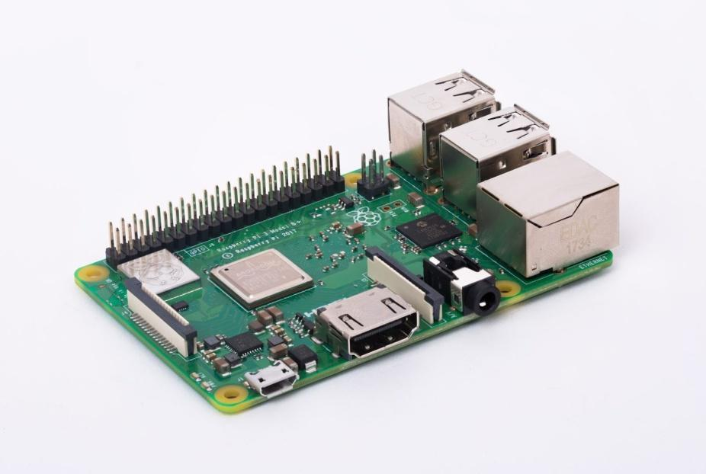

Fig 1.1: Raspberry Pi 3 model B+

The Raspberry Pi is a series of small single-board computers developed in the United Kingdom by the Raspberry Pi Foundation to promote teaching of basic computer science in schools and in developing countries. The original model became far more popular than anticipated, selling outside its target market for uses such as robotics. It does not include peripherals (such as keyboards and mice) and cases. However, some accessories have been included in several official and unofficial bundles.

The organization behind the Raspberry Pi consists of two arms. The first two models were developed by the Raspberry Pi Foundation. After the Pi Model B was released, the Foundation set up Raspberry Pi Trading, with Eben Upton as CEO, to develop the third model, the B+. Raspberry Pi Trading is responsible for developing the technology while the Foundation is an educational charity to promote the teaching of basic computer science in schools and in developing countries.

According to the Raspberry Pi Foundation, more than 5 million Raspberry Pis were sold by February 2015, making it the best-selling British computer.[]](https://en.wikipedia.org/wiki/Raspberry_Pi#cite_note-9) By November 2016 they had sold 11 million units, and 12.5m by March 2017, making it the third best-selling “general purpose computer”. In July 2017, sales reached nearly 15 million. In March 2018, sales reached 19 million.

Most Pis are made in a Sony factory in Pencoed, Wales; some are made in China or Japan.

1.2.2 Arduino UNO R3

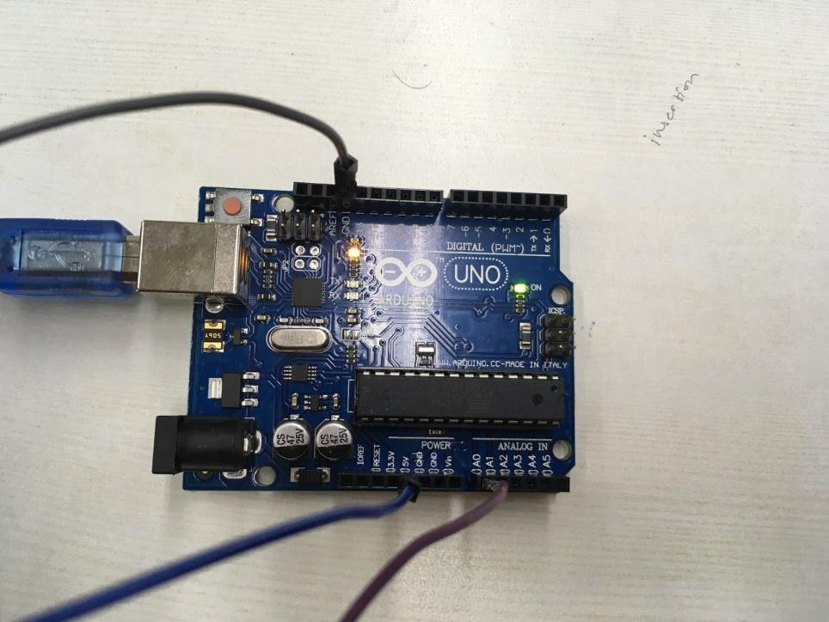

Fig 1.2: Arduino UNO R3

The Arduino UNO is an open-source microcontroller board based on the Microchip ATmega328P microcontroller and developed by Arduino.cc.[]](https://en.wikipedia.org/wiki/Arduino_Uno#cite_note-What_is_Arduino?-3) The board is equipped with sets of digital and analog input/output (I/O) pins that may be interfaced to various expansion boards (shields) and other circuits. The board has 14 Digital pins, 6 Analog pins, and programmable with the Arduino IDE (Integrated Development Environment) via a type B USB cable. It can be powered by a USB cable or by an external 9-volt battery, though it accepts voltages between 7 and 20 volts. It is also similar to the Arduino Nano and Leonardo. The hardware reference design is distributed under a Creative Commons Attribution Share-Alike 2.5 license and is available on the Arduino website. Layout and production files for some versions of the hardware are also available. “Uno” means one in Italian and was chosen to mark the release of Arduino Software (IDE) 1.0.[[1]](https://en.wikipedia.org/wiki/Arduino_Uno#cite_note-Makerspace-1) The Uno board and version 1.0 of Arduino Software (IDE) were the reference versions of Arduino, now evolved to newer releases. The Uno board is the first in a series of USB Arduino boards, and the reference model for the Arduino platform. The Atmega328 on the Arduino Uno comes pre-programmed with a bootloader that allows uploading new code to it without the use of an external hardware programmer. It communicates using the original STK500 protocol. The Uno also differs from all preceding boards in that it does not use the FTDI USB-to-serial driver chip. Instead, it uses the Atmega16U2 (Atmega8U2 up to version R2) programmed as a USB-to-serial converter.

1.2.3 Breadboard

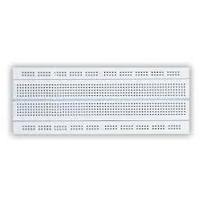

Fig 1.3: Breadboard

A breadboard is a construction base for prototyping of electronics. Originally it was literally a bread board, a polished piece of wood used for slicing bread. In the 1970s the solderlessbreadboard (a.k.a. plugboard, a terminal array board) became available and nowadays the term “breadboard” is commonly used to refer to these.

Because the solderless breadboard does not require soldering, it is reusable. This makes it easy to use for creating temporary prototypes and experimenting with circuit design. For this reason, solderless breadboards are also popular with students and in technological education. Older breadboard types did not have this property. A stripboard (Veroboard) and similar prototyping printed circuit boards, which are used to build semi-permanent soldered prototypes or one-offs, cannot easily be reused. A variety of electronic systems may be prototyped by using breadboards, from small analog and digital circuits to complete central processing units (CPUs).

1.2.4 DHT11 & DHT22 Temperature and humidity sensors

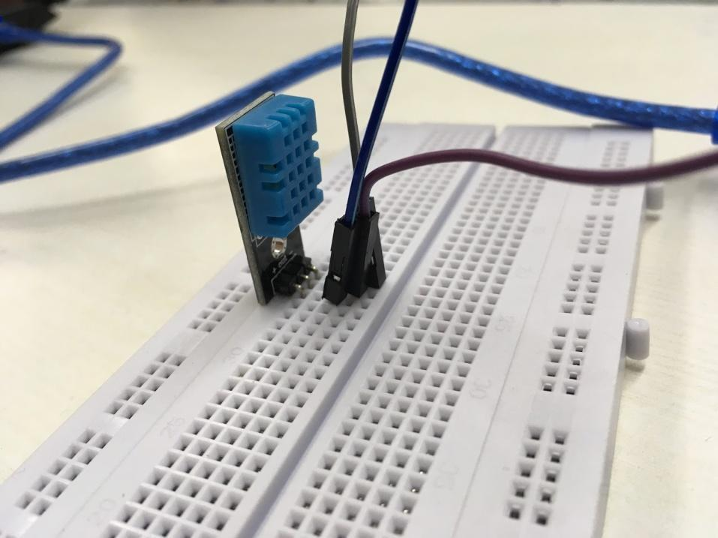

Fig 1.4: DHT11 Temperature and Humidity Sensor

DHT11 Temperature and Humidity Sensor features a calibrated digital signal output with the temperature and humidity sensor complex. Its technology ensures the high reliability and excellent long-term stability. A high-performance 8-bit microcontroller is connected. This sensor includes a resistive element and a sense of wet NTC temperature measuring devices. It has excellent quality, fast response, anti-interference ability and high cost performance advantages.

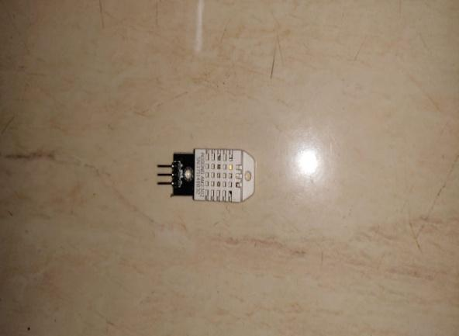

Fig 1.5: DHT22 Temperature and Humidity Sensor

DHT22 capacitive humidity sensing digital temperature and humidity module is one that contains the compound has been calibrated digital signal output of the temperature and humidity sensors. Application of a dedicated digital modules collection technology and the

temperature and humidity sensing technology, to ensure that the product has high reliability and excellent long-term stability.

1.2.5 LM393 comparator

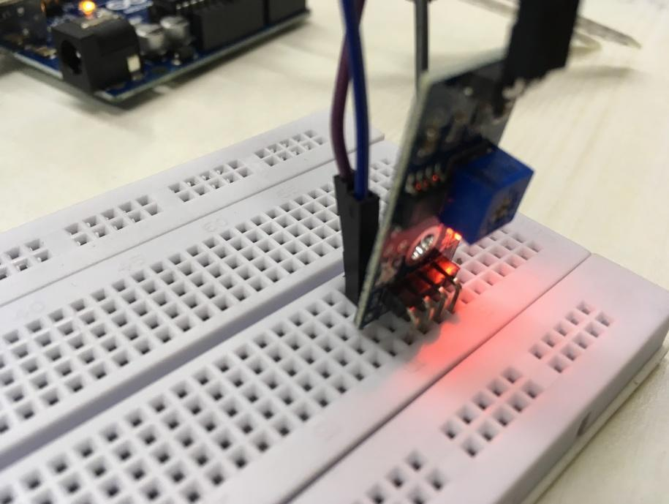

Fig 1.6: LM393 comparator (INACTIVE)

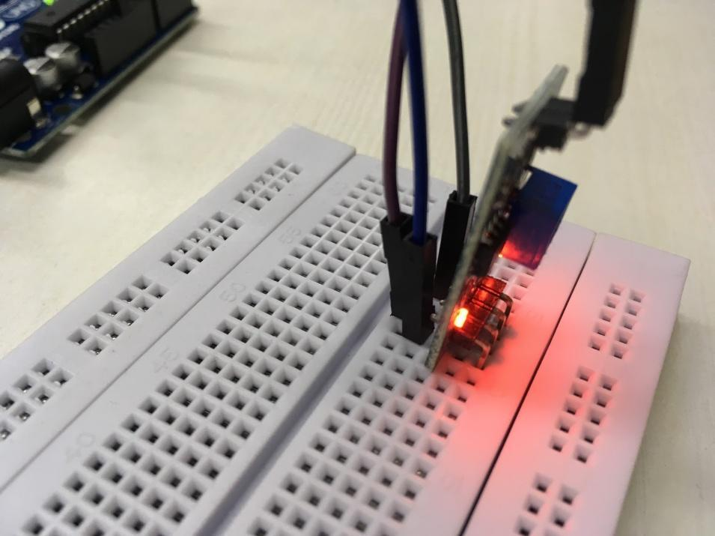

Fig 1.7: LM393 comparator (ACTIVE)

The LM393 comparator consists of 2 independent low voltage comparators designed specifically to operate from a single supply over a wide range of voltages. Operation from split power supplies is also possible.

The comparator also has a unique characteristic that the input common-mode voltage range includes ground even though operated from a single power supply voltage.

1.2.6 Soil Moisture sensor

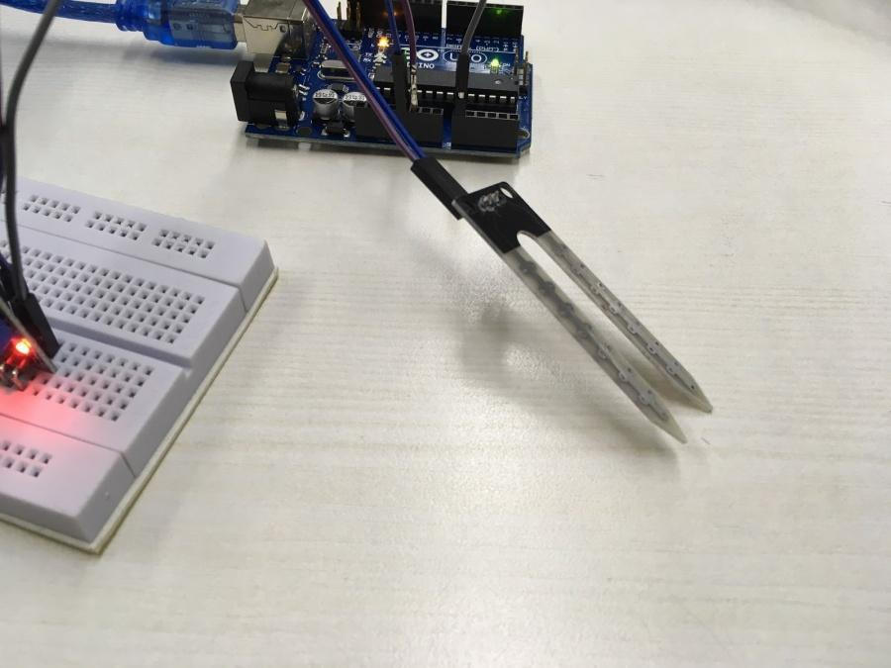

Fig 1.8: Soil Moisture Sensor

Soil moisture sensors measure the volumetric water content in soil. Since the direct gravimetric measurement of free-soil moisture requires removing, drying, and weighting of a sample, soil moisture sensors measure the volumetric water content indirectly by using some other property of the soil, such as electrical resistance, dielectric constant, or interaction with neutrons, as a proxy for the moisture content. The relation between the measured property and soil moisture must be calibrated and may vary depending on environmental factors such as soil type, temperature, or electric conductivity. Reflected microwave radiation is affected by the soil moisture and is used for remote sensing in hydrology and agriculture. Portable probe instruments can be used by farmers or gardeners.

1.2.7 Connecting wires

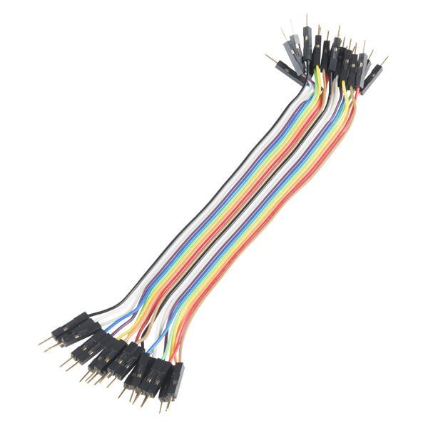

Fig 1.9: Connecting Wires

Needed to do the necessary connections between the sensors, Arduino and the raspberry pi, along with that cables for power, USB cables to connect a keyboard and an optical mouse are also necessary.

**1.3 Software Specification**

1.3.1 A smart phone running Android OS.

For running the farm ecosystem, the user needs to be shown all the data that is being monitored by the sensors and this will be done by developing an application. This application will be built for android users to start with, thus we require a smartphone with the Android OS.

1.3.2 Android Studio IDE

Since we plan to make an application on the Android OS, we need an IDE that we can use to code the application and for this we will be using the android studio IDE.

1.3.3 Arduino IDE

The Arduino IDE is a programming environment where the code for the Arduino board’s actions can be written and executed. The code section consists of 2 parts:

The first part is the void setup() function where all the initializing information about the pins of the Arduino are entered. This tells the Arduino which pin to use as an input and which pin can be used as an output.

The second part is the void loop() function. The loop function is repeated continuously because it is called by a hidden loop that controls the execution of the Arduino program. In other words, the loop function is the body of a loop that is running in a master (or main) program.

1.3.4 A Raspberry Pi running Raspbian OS

The Raspberry Pi needs to be loaded with an OS so that operations can be performed on it in the first place. We decided to install the Raspbian OS for this. Raspbian is the official licensed OS offered by Raspberry Pi and it is based around the Debian Linux OS which offers a convenient interface.

**CHAPTER NO. 2**

**REVIEW OF LITERATURE**

**2.1 Architecture**

The main issue with agriculture in India, according to one of the papers read is the lack of information during the growth cycle which ultimately results in a loss. The key issue in the current domain is utilization of resources like man-power and water which is lacking in many parts of the country. The authors describe various IOT based improvements done by different people for agriculture purposes. The authors also divide the entire model to smaller sections which they loosely classify as, Knowledge base, Realized Inputs, Knowledge Acquisition, Knowledge flow, & Monitoring Interface. The knowledge base consists of data that is stored that is used to assist the individuals doing the farming, realized inputs consisted of market information and other information that would help the farmers, knowledge acquisition and knowledge flow referred to the acquisition of data from already established and reliable methods and the flow of the data from one module to another respectively.  The monitoring interface consisted of further subdivisions where the authors of the paper put forward the hardware and software requirements required to build the system proposed by the authors. The hardware section consisted of sensors and launchpad that is usually used to gather data, the software on the other hand consisted of software such as Energia MT and Blynk along with Arduino IDE and the use of Internet to connect various devices over it, the last section consisted of the system architecture solely responsible to provide certain inputs during set interval of time.

A smart farm can be built and implemented in several ways but what needs to be ensured is how efficiently and how accurately data can be obtained from the hardware components for e.g. the data values electrochemical sensors.

The authors from King Mongkut's University of Technology Thonburi (KMUTT) propose the following architecture to make a self-sufficient smart farm. The first step involves the collection and generation of raw data from the sensors that will be used in the farm. The output generated by sensors are the voltage values. The second step involves applying the process of Kalman Filtering on the output values. The reason we apply this process is because it is possible that these sensors might sometimes give inaccurate values. Kalman filtering is a recursive algorithm which tries to obtain the most accurate value possible as a final value which can then be formatted and made into user understandable data. The third step is where

the information about the region’s weather is gathered. This is done by linking the control system to a reliable external weather site. The weather data includes all the data from the

past, present as well as the forecasted weather in that region. This data is stored either locally or on a cloud. The weather data will be used to make key decisions in the next step. The fourth step is where the collected weather data can now be used to create a decision tree for the system and the system can independently predict the weather. The final step involves the combination of the second and the fourth step to create a decision tree. The decision should now take decisions on its own to keep the produce healthy. For e.g. if the weather is sunny the system will independently water the plants to keep the moisture levels stable. The authors have proposed a control system for intelligent farming. To create a decision, the model requires two important information pieces which are the sensed data from the sensors in the plot and the weather condition. To make the sensed data accurate, authors have applied Kalman filter to remove noise. Also, the authors have generated a decision tree model to predict the weather condition. Based on this information, authors have set up rules for creating a decision in our control system on whether watering and roofing system should be on or off Moreover, authors have also provided functions for users to manually control the watering and roofing systems via their mobile application.

The authors from the Chinese Academy of Sciences talk about the presence of the existing WSNs, mainly about motes deployed by Intel Corporation in 2002. They also provide details as how the entire process worked along with what components were utilized to do so. Various materials that would be required to build the system were also delved into and consisted of Wireless nodes which would provide gateway, route and sensor nodes for the proposed model and allowing communication between sensor nodes and gateway nodes. A Video Monitoring system is also implemented that would allow the authors to monitor the growth of the plants in real time instead of having a passive means of monitoring. Software such as a Human-Interface System consisting of a command and a display part, database to store useful data and a dormancy mechanism along with an alarming mechanism is used to maintain the network that would extend the life range of the network. The authors completed a simulation of the system using a greenhouse experiment and an in-field experiment. By keeping the rate of packet loss low, the system was a decent success with it providing the farmers with good feedback.

Researchers at Maejo University in Thailand applied the methodology of IOT with a sensor to measure and monitor humidity levels in the Lingzhi mushroom farm. The humidity data processed through NETPIE, a cloud-based platform-as-a-service that facilitates interconnecting IoT devices (“things”) to the cloud. This humidity data was stored into a NET FEED and made accessible on mobile devices and computers online through NET FREEBOARD. The data obtained was used to automate sprinkler and fog pumps in order to irrigate the mushroom. Farm status pushes notifications through LINE API using the LINE application.

**2.2 Sensors and Colorimetry**

Researchers at Mepco Schlenk Engineering College, Tamil Nadu, India used a low-cost soil moisture sensor, the DHT11 humidity and temperature sensor and a Light Dependent Resistor (LDR) in which as the light intensity increases, the resistivity decreases and vice versa, to detect light intensity in order to obtain plant growth data. Using NRF24LO1 transmitter and receiver and Ethernet connection at receiver ends, continuously monitored field data was then sent to the web server. Sensor data is then stored in a database. Using wireless transmission, the data acquired from sensors are transmitted to the web server. An NRF24L01 module is used to enable wireless transmission between the field and the web server. Arduino boards are used to connect the transmitter and receiver modules. The transmitter is placed at the field end and the receiver is placed at the system end. The receiver receives data from the various transmitters installed at the field end. Using Ethernet, the receiver at the system end is then connected to the web server. A web application is designed to analyze the data received from the sensors, check with the recommended threshold values of moisture, humidity, temperature and light intensity. After values are analyzed and reported, decision making is then done at the server end in order to automate the irrigation process. If soil moisture is lesser than recommended threshold value, irrigation motor is accordingly switched ON and if the soil moisture exceeds the recommended threshold value, irrigation motor is then switched OFF.

Researchers at R V College of Engineering, Bangalore, India proposed a model that used “colorimetry” to collect soil nutrient data, manually done requiring around 30 minutes to get results. Sensor using LED and Photodiode is used to collect colorimetry results and is passed to PC (Arduino). Analysis of results is done and values are compared with optimum nutrient (NPK) values for different crops and field sizes Calculation of maintenance dosage and quantity of fertilizer to be added using data on nutrient deficiencies and the % content in nutrient solution (N in urea, etc.) and nutrient results from colorimetry test. Using relay valves for each separate nutrient solution (time controlled based on sensor results) and a mixer, according to calculations, nutrients are passed to mixer and are finally sent to soil through a relay valve, all automated.

Researchers at BMS College of Engineering, Bengaluru, India proposed a model to analyze the nutrients of the soil in real-time by measuring Nitrogen (N), Phosphorus (P), Potassium (K) values by using sensors. This obtained data from the sensors is then sent to the IBM Bluemix cloud. IBM Bluemix is a cloud platform as a service (PaaS) developed by IBM to build, run, deploy and manage applications on the cloud. The values obtained are then stored in a cloud database which allows access to the data from anywhere, anytime. The formula discussed in the paper to calculate Nitrogen values in soil using voltage deflection is shown below.

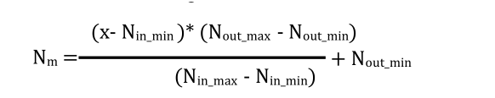

The same formula is applied for Potassium and Phosphorus by substituting the value of N.

A mobile application was also developed to provide information related to the nutrient i.e. NPK values present in the soil. The application also allows for a farmer who wishes to grow a specific crop of interest, suggestions on amount of fertilizers to be added to the soil to ensure healthy growth of crops.

**2.3 Automation**

The authors from Easwari Engineering College in Tamil Nadu, India propose the implementation of an Agrobot – which are simply robots made for agriculture and can work alongside automation to perform operations that are usually done by humans working the field, like mowing and weed removal. The implementation of autonomous robots will make farming more consistent and efficient compared to today’s standards. The authors also provide details on the advantages of using automated techniques like, bots can work nonstop and do so in any kind of environment without hindering their speed or precision and also detect diseases and other issues that might affect the crops. Due to the bots being lighter than

the heavy machinery used today it does not adversely affect the soil in any shape or form, this along with the utilization of Image Processing is also proposed to be used for the purpose of mechanics such as fruit picking where the identified fruits are picked up using an hydraulic arm as well as the spraying of pesticides in areas only affected by pests as recognized by the processing methods.

The proposed model by the researchers from Easwari Engineering College in Tamil Nadu, India is the implementation of smart farm sensing system along with a movable smart irrigator mounted on a mechanical bridge. The overhead crane containing the smart irrigator will travel along the bridge and the system will be powered by using solar panels. Infrared sensors are also equipped on the proposed model and are used as a feedback sensor to maintain and regulate the speed of the motor. An optocoupler isused which when interfaced with the microcontroller will control and activate one of the connected motors. The smart irrigator present will auto fill the system when it detects a decrease in one of the detected quantities of a commodity. The authors also implemented the system on the field and found that the proposed model was efficient in its working and served the purpose of automating the entire process of farming and in turn eliminating the various difficulties faced in manual farming.

**2.4 Cloud Storage**

The researchers from Galgotias University, India propose a cloud storage system for the purpose of creating backup of data obtained from the sensors used in the farm. This stored data should be accessible at any time and stored safely and the architecture of the storage system should be robust as well as efficient. The system that the authors proposed to make sure that it will be efficient, is a cloud storage system. The proposed framework for a cloud storage system is considered with the key idea of optimizing the storage using compression algorithms and guaranteeing the safety of the data when transmitted through the network. The layers and the underlying process used are a Sensor Network, Cloud Storage and a Pre-Existing Client Framework. The first step, the Sensor network is where the data is generated and collected. This data is transmitted using wireless networks to the modem. To optimize the storage of the modem, the data is compressed and its size is reduced through various techniques. The data is also encrypted to ensure the security of the data. The compressed and encrypted data is then transferred to the cloud storage which forms the second layer. In the cloud, the obtained compressed and encrypted data from the sensor network and stored. The

owner of files/data can give the permission to the cloud to decrypt and decompress the data and hence process this data. The cloud can independently generate reports on this data. These reports can use the same compression and encryption algorithms to store these reports in the cloud for the user. The next step is the client’s pre-existing framework. Here the data or signals are received from the cloud applications through internet. Whenever these sensors are required to be triggered, the modem just like the sensor network does the decrypting and decompression of the data and the target actuator is activated.

The authors also talk about some data compression techniques that can be used based on what kind of data is being stored in the cloud. If the data is in the form of a video the suggested compression technique is H.264, because of its high frame rates, its increased image quality and also because it has the least bandwidth utilization. For data that is in the form of an image, JPEG is the recommended technique because of its high flexibility. This is because the end result can be a high-quality image, a fairly compressed image or a highly compressed image with a reasonable picture quality. Lastly, if the data is in text form, the advised compression technique is LZW. The main reason is LZW diminishes the file size the most efficiently compared to other techniques, and takes the least amount of time to decompress the data. Since IoT involves real time processing and requires the latency rate to be low LZW is a reliable technique of compression for the data in text form. For data security the suggested algorithm is the Advanced Encryption Standard (AES) algorithm. This algorithm uses the same key for both encryption as well as decryption so the time it takes is quite low. It is also flexible. The user can decide how many bits there should be in a key, 128,192,256 and so on. The higher the number of bits in the key, the greater the level of security but greater the latency time as well.

**CHAPTER NO. 3**

**ANALYSIS & DESIGN**

**3.1 Hardware Design**

The prospective vertical farming system is represented in a block diagram as shown below. The vertical farm system, will have detachable blocks to serve a more modular purpose for urban use.

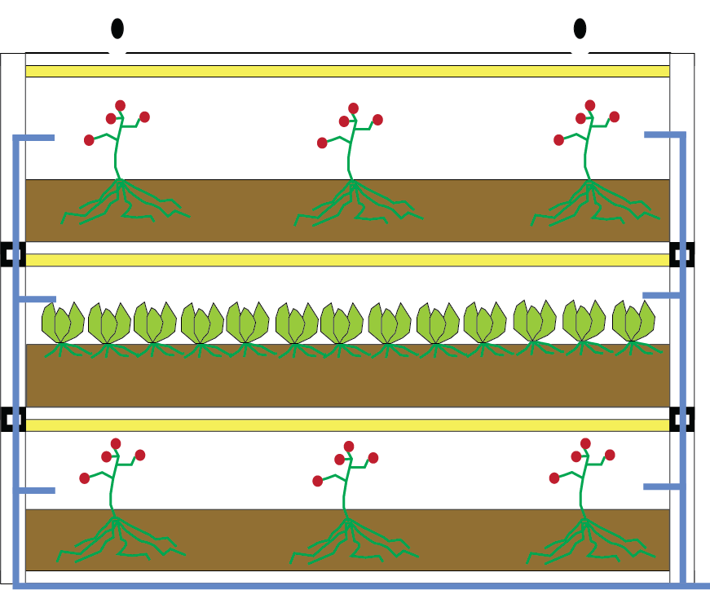

Fig 3.1: A visual representation of the vertical farm ecosystem

The entire system’s purpose is that it can be attached to the urban environment and not use up valuable space in an already restricted space. The below figure displays the detachable use of the same figure and display the modularity of it.

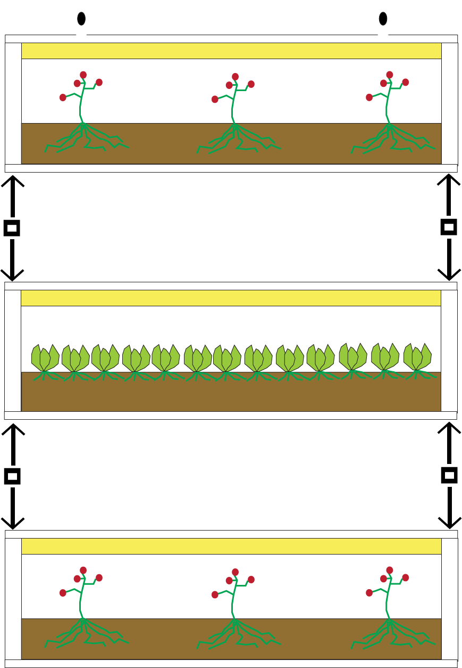

Fig 3.2: A visual representation of the modularity aspect of the system.

The system is self-contained, containing the sensors required for the data logging and the mechanisms to provide water to the system as shown in the figure below.

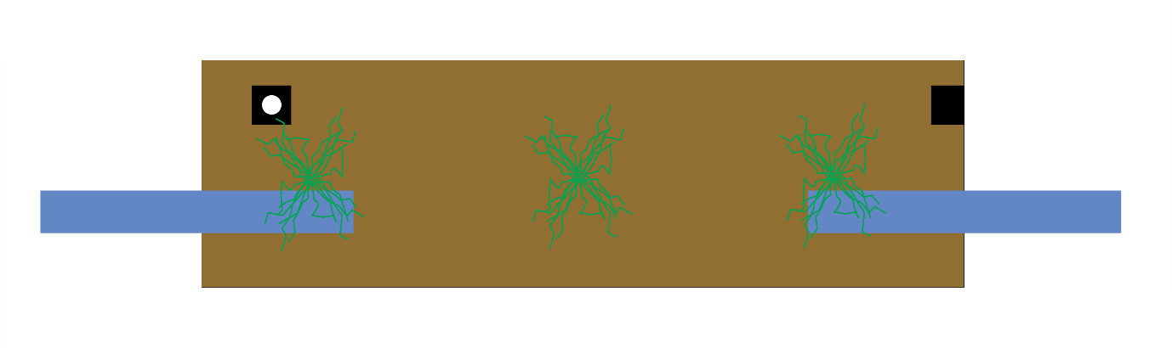

Fig 3.3: Figure displaying presence of sensors and water outlets.

**3.2 Software Design**

The sensor data that we obtain needs to be stored somewhere. This could be in the local memory or on a storage cloud as in our case. We used the Thingspeak cloud service because of its integration with MATLAB.

When a channel is created on the Thingspeak service, the user of the channel obtains a key called as the “Write API key”. On the Raspberry Pi, a code is written in Python. In this code, we describe the number of fields we want in our cloud service. In order to establish a connection between the Raspberry Pi and the Thingspeak channel, we use the Write API key that was mentioned earlier.

When the Python code is run, the data is shown as an output on the Python Terminal and the same data values are also plotted as a graph on the Thingspeak Channel in their respective fields that were described in the Python code. The design for the Android Application includes the ability to select from a list of plants that is curated by us due to the various needs and requirements of plants that would not be able to grow in such a restricted area. An active tracker displaying the details of the plant and some general knowledge about the same is also implemented in the application itself. The application also has a timer that would display when the said plant was last watered.

**CHAPTER NO. 4**

**METHODS IMPLEMENTED**

The implementation would be divided into multiple phases, primarily beginning with the procurement of data based on different conditions of the soil and the environment along with the procurement of sensors that can provide information regarding the same. Arduino and Raspberry Pi would also be used as a means to gather data from the sensors and plot it properly for further utilization and understanding the requirements of the soil based on the plants. A cloud storage solution can also be implemented to backup all data to a central location and reduce the amount of data stored locally. Development and implementation of a smartphone application to provide data from the cloud storage and allow remote control over the Arduino board. The model will also have automated valves which will be connected to the smartphone application through the Arduino board. An extensive testing of the sensors and the data obtained, testing of the cloud storage and mobile application display connectivity, extensive testing of the entire automation process and finally condition testing of the entire Smart Farm System will be done to ensure recommended standards of smart technology and healthy produce.

A UML diagram was created in order to understand the project’s flow with time and which modules will interact with one another and how they will do so.

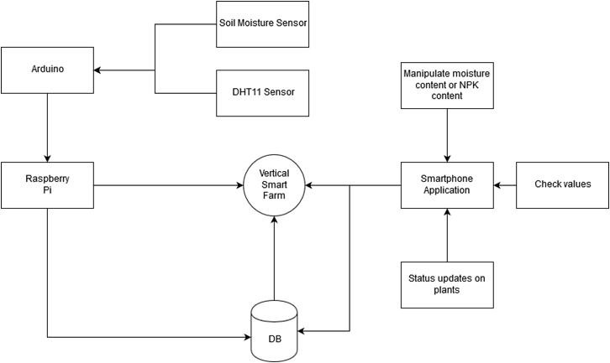

Fig 4.1: Flowchart for system implementation

The implementation of the project as a whole was divided into 4 major modules. These modules at the end would result in a unified system that would be interconnected to each other. The modules are as follows:

1. Data Gathering

This module will consist of the sensors, which will retrieve the data, Arduino Uno, which will capture the data from the sensors and then send it ahead to the Raspberry Pi.

1. Data Processing and Updating

This module will consist primarily of the Raspberry Pi and Arduino Uno. The Arduino will convert the values to human understandable values and send them to the Raspberry Pi. It will also calculate approximate values of NPK content on the soil

from the data sent to it from the sensor. The Raspberry Pi, will create a readable .csv file or .txt file and keep appending the data as well as send the data through the cloud to a database.

1. Data Storage

This module consists only of the database that will receive the data from the system through the internet and will send it to the Smartphone Application built for the end user.

1. User Interface for value manipulation

This module will consist of the Android Application built for the end user. This will the user to increase the moisture content or NPK content if they wish to do so, or simply monitor the values captured by the automated system. This will also allow the user to receive notifications if something is wrong or if the plant is ready for harvesting and a new seed can be planted.

**CHAPTER NO. 5**

**RESULTS & DISCUSSION**

Based on the literature review, we were able to write and publish a review paper that was presented at an IEEE conference in Mysore, India. We were able to summarize that the problem of harmful pesticide infested produce can be solved by allowing a consumer to grow produce self-sufficiently, subsequently decreasing the load on conventional farming techniques.

Urban consumers today, due to lack of time, need a quick and efficient solution in order to tackle their problem and hence a Vertical Smart Farm System is proposed which can automate the entire farming model, thus allowing for new-age urban consumers to smartly and effectively embrace the all-beneficial synergy between Technology and Farming.

We conducted an experiment for 23 days to determine the moisture, temperature and humidity from a baby tomato plant. The following images show the plant and the data we had gathered.

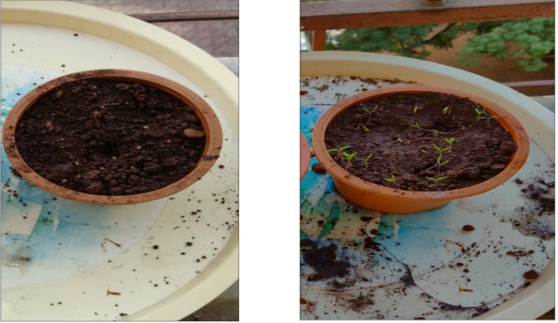

Fig 5.1: Plant before growing and in its stage of sprouting

The following table contains the results obtained by using sensors and the Arduino on the plant.

|  |  |  |  |
| --- | --- | --- | --- |
| Date | Temperature | Humidity | Moisture |
| 1/8/2019 | 29 | 42% | 98% |
| 1/9/2019 | 26 | 40% | 99% |
| 1/10/2019 | 27 | 38% | 98% |
| 1/11/2019 | 26 | 42% | 100% |
| 1/12/2019 | 28 | 40% | 99% |
| 1/13/2019 | 27 | 37% | 100% |
| 1/14/2019 | 28 | 40% | 100% |
| 1/15/2019 | 29 | 40% | 100% |
| 1/16/2019 | 29 | 40% | 97% |
| 1/17/2019 | 30 | 38% | 97% |
| 1/18/2019 | 28 | 42% | 95% |
| 1/19/2019 | 27 | 41% | 100% |
| 1/20/2019 | 27 | 40% | 100% |
| 1/21/2019 | 29 | 37% | 97% |
| 1/22/2019 | 28 | 37% | 96% |
| 1/23/2019 | 26 | 40% | 98% |
| 1/24/2019 | 27 | 39% | 97% |
| 1/25/2019 | 28 | 37% | 100% |
| 1/26/2019 | 29 | 36% | 100% |
| 1/27/2019 | 29 | 35% | 95% |
| 1/28/2019 | 30 | 31% | 97% |
| 1/29/2019 | 32 | 40% | 96% |
| 1/30/2019 | 31 | 30% | 99% |
| 1/31/2019 | 30 | 31% | 100% |

Table 5.1: Moisture, temperature and humidity data from the plant.

We were also able to connect the Raspberry Pi with the Thingspeak channel. What this entailed was that the written code would execute and fetch the required data. This fetched data would then be transferred to the Thingspeak channel, using the Channel API key written in the code. The data is then plotted in its respective field on the Thingspeak channel.

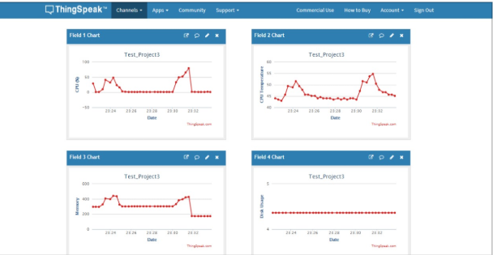

Fig 5.2: Data plots obtained on Thingspeak

We also have an android application which shows the user a list of plants that are available to add in their vertical farm. Each plant has a description and the frequency of how often it needs to be watered. If the “+” sign is clicked, then the plant will get added to the farm.

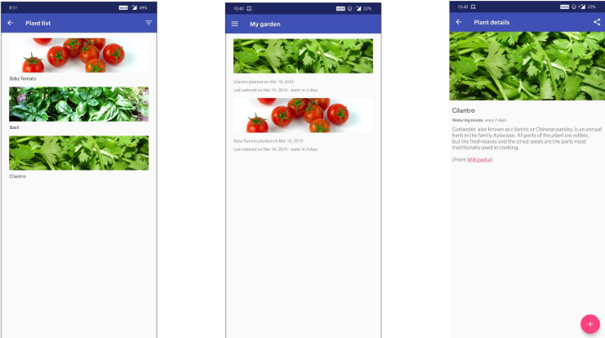

Fig 5.3: The Android Application screenshots

**CHAPTER NO. 6**

**CONCLUSION & FUTURE SCOPE**

The problem of harmful pesticide infested produce can be solved by allowing a consumer to grow produce self-sufficiently, subsequently decreasing the load on conventional farming techniques. Urban consumers today, due to lack of time, need a quick and efficient solution in order to tackle their problem and hence a Vertical Smart Farm System has been proposed that automates the farming model right from soil and plant condition data acquisition, storage and analysis of the data, availability of data on mobile devices remotely connected via Wi-Fi and the Internet, automation of farm maintenance processes, thus allowing for new-age urban consumers to smartly and effectively embrace the all-beneficial synergy between Technology and Farming.

The future implementation of the system will involve constructing the entire model vertically. This is done in order to overcome a number of problems regarding shortage of space in urban landscapes while utilizing IoT and Automation and the best architecture and techniques from the aforementioned research. After the successful implementation of the Smart Farm System using the proposed model above, the entire structure will be installed vertically for utilization of the system in compact urban spaces. The automation and the smartphone application will highly benefit any non-professional farmer interested in farming but lacking the ability or knowledge or time to do so.

**REFERENCES**

[1] Mohan Guruswamy, “Food for thought: India will have 1.7 billion people by 2050. How will it feed them all?”, May 2017, Scroll [Online].

[2] Mohanraj I, Krithika Ashokumar, Naren J, “Field Monitoring and Automation using IOT in Agriculture Domain”, 6th International Conference on Advances in Computing & Communications [ICACC], September 2016.

[3] Narayut Putjaika, Sasimanee Phusae, Anupong Chen-Im, Dr. Phond Phunchongharnm Dr.Khajonpong Akkarajitsakul, “ A Control System in an Intelligent Farming by using Arduino Technology”, Fifth ICT Internation Student Project Conference (ICT -IPSC), 2016.

[4] Hui Chang, Nan Zhou, Xiaoguang Zhao, Qimin Cao, Min Tan, Yongbei Zhang, “ A New Agriculture Monitoring System Based on WSNs”, ICSP, 2014.

[5] Oran Chieochan, Anukit Saokaew, Ekkarat Boonchieng “IOT for Smart Farm: A case study of the Lingzhi Mushroom Farm at Maejo University”, 14th International Joint Conference on Computer Science and Software Engineering, 2017.

[6] Rajalakshmi.P, S.Devi Mahalakshmi, “IOT Based Crop-Field Monitoring And Irrigation Automation”, 10th International Conference on Intelligent Systems and Control, 2016.

[7] Amrutha A, Lekha R, A Sreedevi, “Automatic Soil Nutrient Detection and Fertilizer Dispensary System”, International Conference on Robotics: Current Trends and Future Challenges, 2016.

[8] Shylaja S.N., Dr.Veena M.B., “Real-Time Monitoring of Soil Nutrient Analysis using WSN”, International Conference on Energy, Communication, Data Analytics and Soft Computing, 2017.

[9] Amrita Sneha A., Abirami E, Ankita A, Mrs R Praveena, Mrs R. Srimeena, “Agricultural Robot for Automatic Ploughing and Seeding”, IEEE International Conference on Technological Innovations in ICT for Agriculture and Rural Development, 2015.

[10]   Chetan Dwarkani M., Ganesh Ram R, Jagannathan S, R. Priyatharshini,” Smart Farming System Using Sensors for Agricultural Task Automation”, IEEE Internation Conference on Technological Innovations in ICT for Agriculture and Rural Development, 2015.

[11]   Pallavi Srivastava, Navish Garg, “Secure and Optimized Data storage for IoT through Cloud Framework”, International Conference on Computing, Communication and Automation (ICCCA), 2015.

**PUBLICATION BY THE CANDIDATES**

A Review paper titled “Vertical Farming Using IoT & Automation” was published by us under the guidance of our mentor Professor Ameyaa Biwalkar at the 2018 Third International Conference on Electrical, Electronics, Communication, Computer Technologies and Optimization Techniques (ICEECCOT), December 2018. The conference was held at the GSSS Institute of Engineering and Technology for Women, Mysore and was approved by IEEE.